Firefox https://moodle.fer.hr/mod/quiz/review.php?attempt=649875&cmid=1303

Moja naslovnica / Moji e-kolegiji / tuum / Opći dio / Kviz iz laboratorijskih vježbi 3 i 4 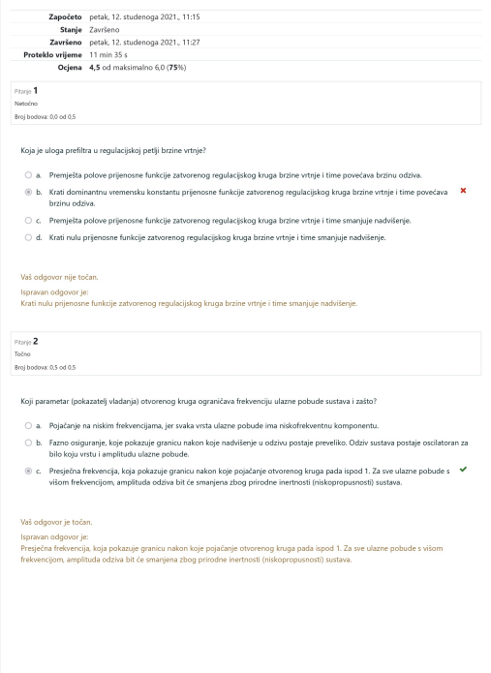1 of 6 12/11/2021, 11:31

Firefox https://moodle.fer.hr/mod/quiz/review.php?attempt=649875&cmid=1303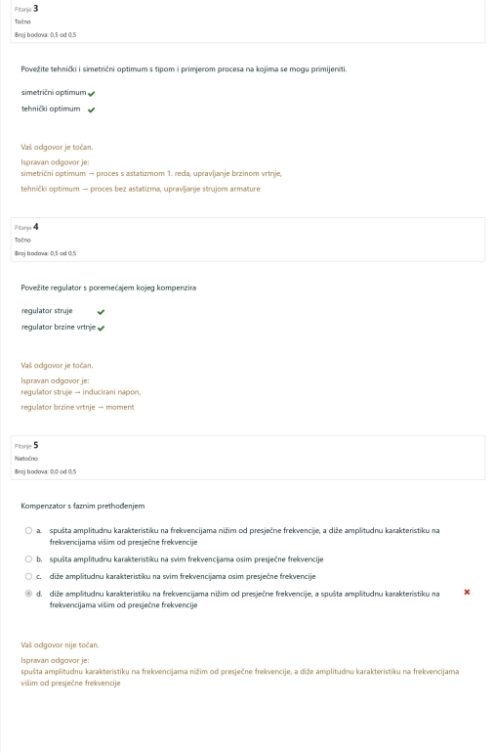2 of 6 12/11/2021, 11:31

Firefox https://moodle.fer.hr/mod/quiz/review.php?attempt=649875&cmid=1303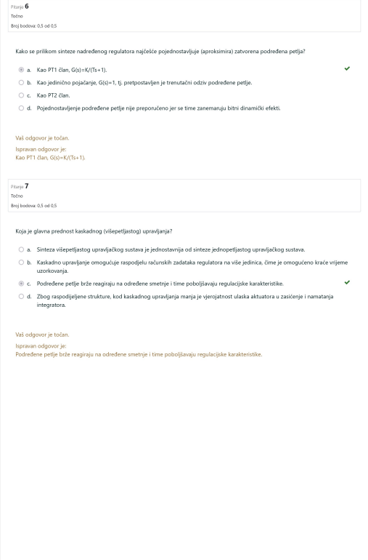3 of 6 12/11/2021, 11:31

Firefox https://moodle.fer.hr/mod/quiz/review.php?attempt=649875&cmid=1303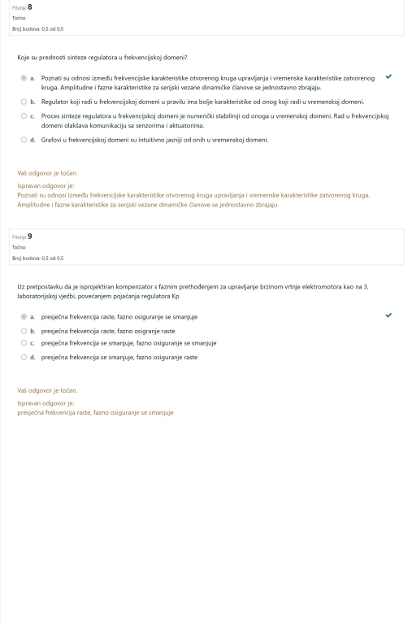4 of 6 12/11/2021, 11:31

Firefox https://moodle.fer.hr/mod/quiz/review.php?attempt=649875&cmid=1303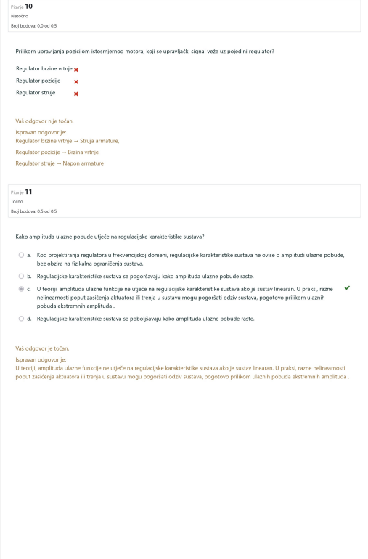5 of 6 12/11/2021, 11:31

Firefox https://moodle.fer.hr/mod/quiz/review.php?attempt=649875&cmid=1303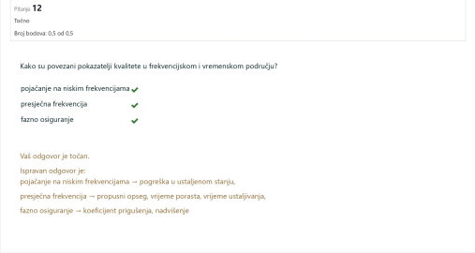

6 of 6 12/11/2021, 11:31